Adversarial Search
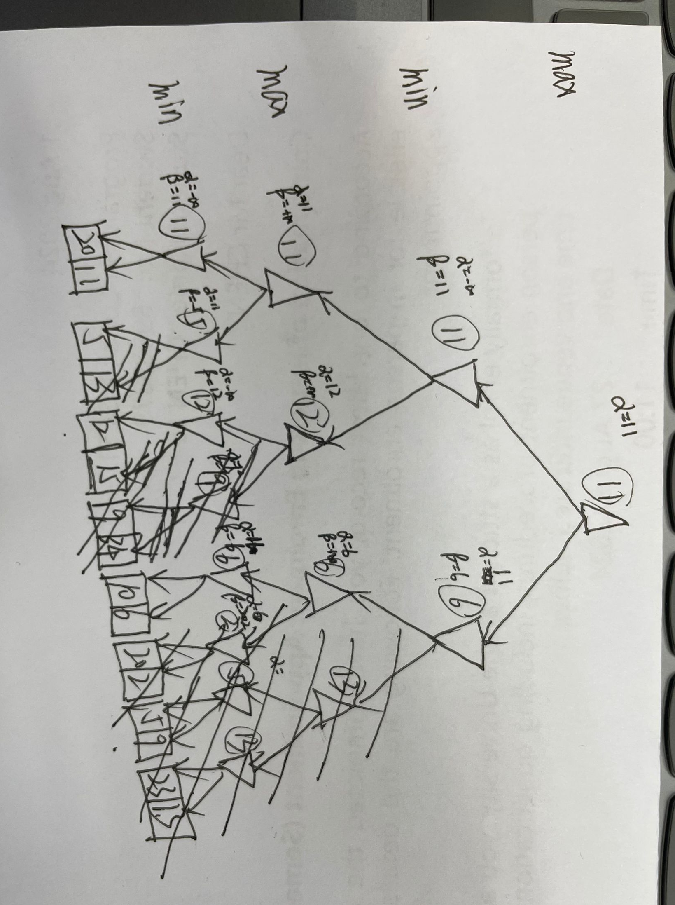
Expectimax
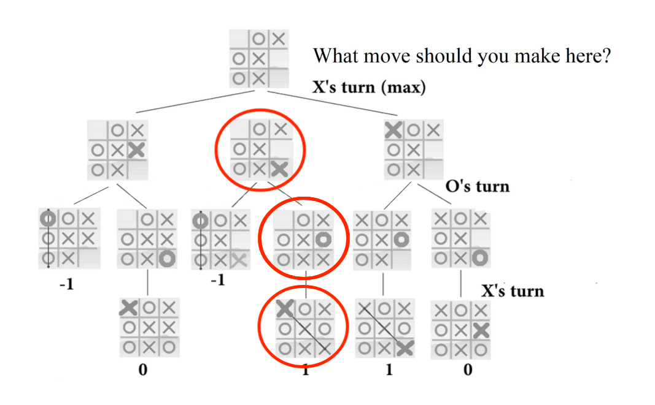
Choose the lower right corner, Olivia is more likely to be in the middle, and the expected value is -1*1/4+1*3/4=1/2. Choose the upper left corner, Olivia is more likely to be in the lower right corner, and the expected value is 1*1/4+0*3/4=1/4. So choose the lower right corner.

